DESIGN SMARTER
3D PRINTING NEED TO KNOWS
Cameron Collins
COLLINS CREATIONS 3D Unit 2, ESAM, Carluddon Technology Park, Saint Austell PL26 8TY
Copyright 2019
DESIGN SMARTER
3D PRINTING NEED TO KNOWS

So you want something 3D Printed…?

GREAT!

But before we get started, CC3D would just like to give you some free 3D printing advice before making your 3D dream designs a reality.

OVERHANGS

Overhanging features are, without a doubt, one of the most important factors when designing a model. In general you want to avoid unsupported features at angles greater than 45 degrees as these quite often end up producing undesirable blemishes and artefacts on the underhanging surface or at worse, pose a risk of failing midway through printing. Using supports can prevent this to a large degree but take note that these will need to be manually removed from the final print again often leaving small blemishes and artefacts.

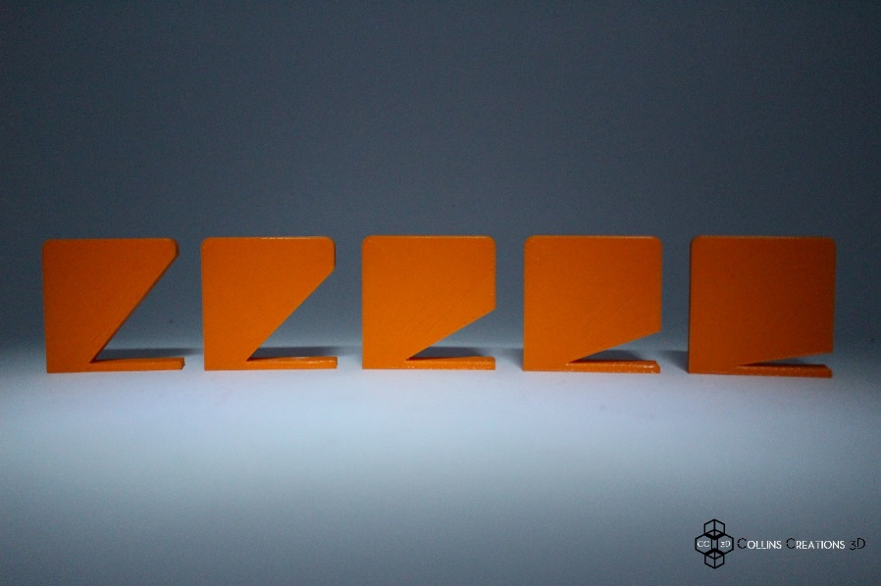

You may wish for us to clean these blemishes away, which we can certainly do for you as an additional finishing service.

FILLETS AND CHAMFERS

Adding fillets to your 3D model can substantially improve the final strength of a printed part, as is what can be seen when creating Pins and Extrusions.

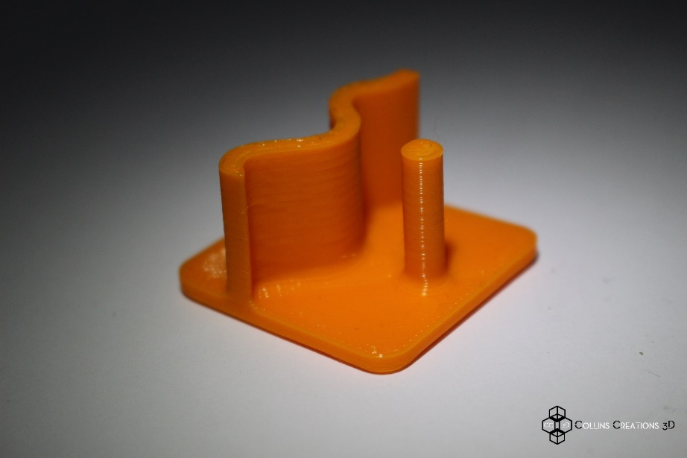

Fillets can also be very useful when printing small overhang features eliminating the need for support material in some, but not all cases.

PINS AND EXTRUSIONS

Pins and columns are often used in electronic and end product casings. For best results avoid designing pins with a diameter smaller than 3mm.

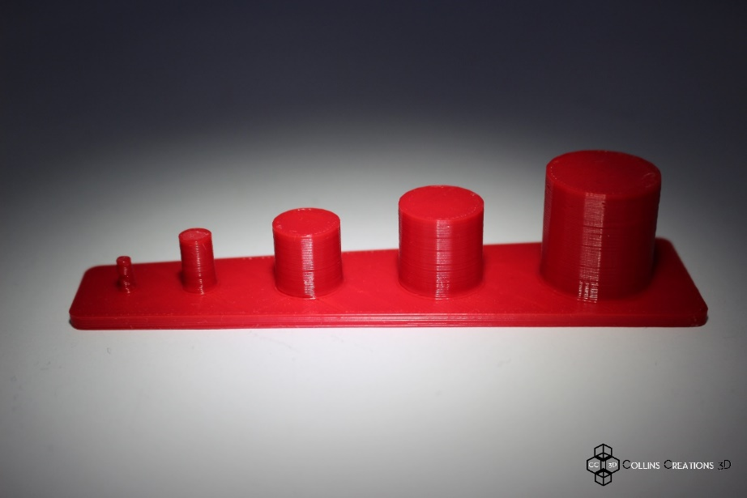

TIP: Add a chamfer or fillet at the base of your pins to provide a stronger base section and increased part strength.

HOLES AND CUT EXTRUSIONS

This is another feature present in almost every model especially jigs, fixtures and mechanical parts.
We recommend designing holes to be 2% to 4% larger than the desired diameter.

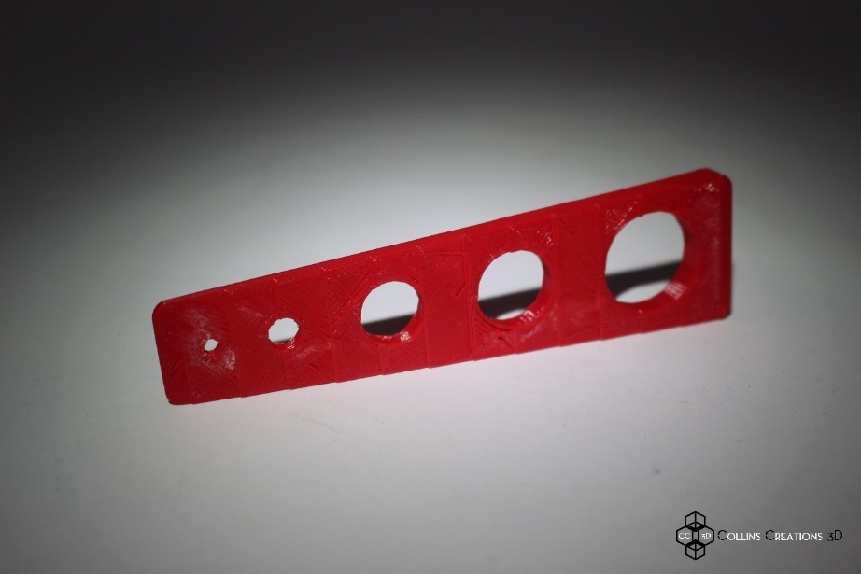

TIP: When dimensional accuracy is paramount we suggest designing smaller diameter holes and later drill out these holes to the required dimension once printed.

WALLS

Vertical features are often overlooked but they play a very important part in whether or not your print will be successful and how strong the final result will be.
We always recommend designing walls with a thickness of at least 1mm.

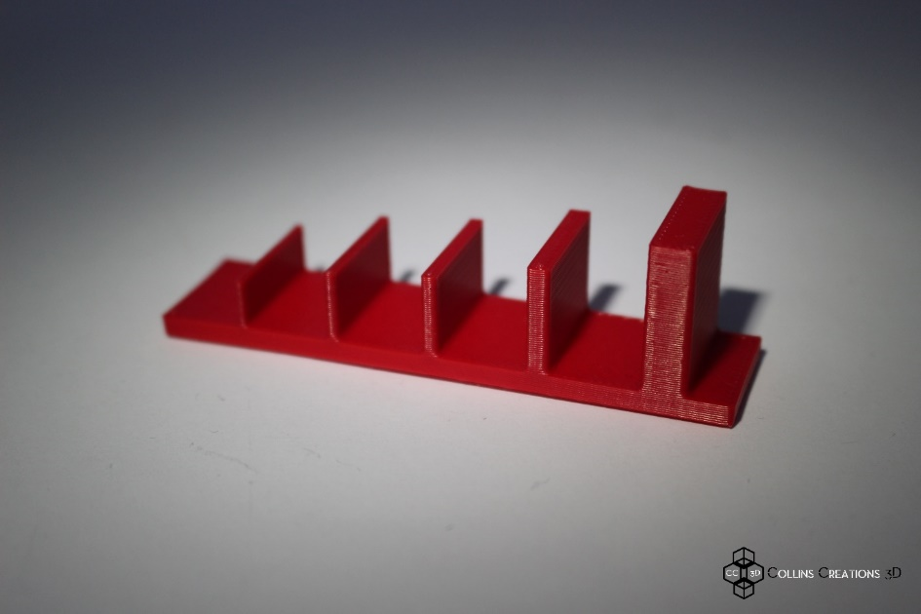

TIP: Once again, add a chamfer or fillet at the base of your wall if possible to provide a stronger base section and increased part strength.

ENGRAVING AND EMBOSSING

Engraving detailed features requires a minimum line thickness of 1.2mm and a depth of at least 0.3mm for suitable results.
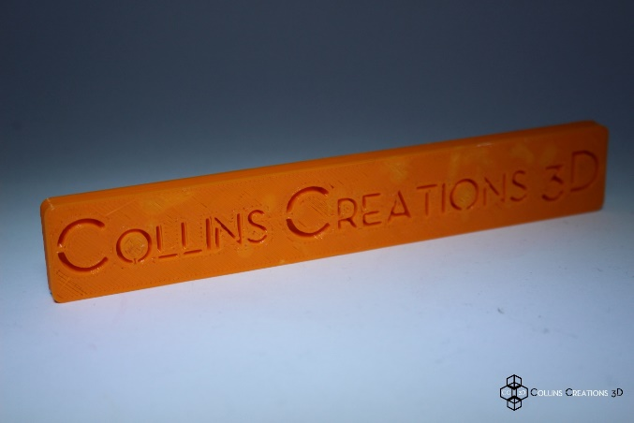

For embossing we are looking at 2.5mm line thickness and a minimum depth of 0.5mm for suitable results.

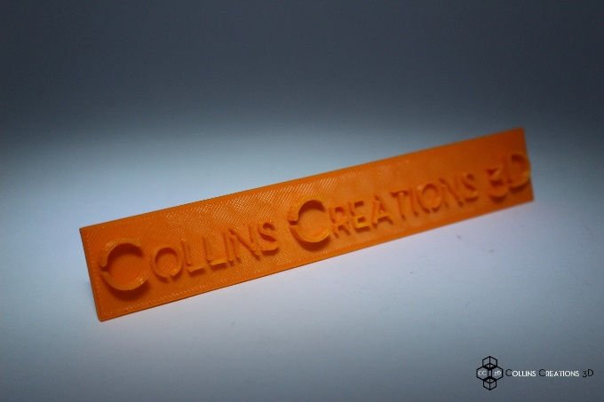

TIP: As well as applying the recommended thicknesses and depths to your embossing and engraving, don’t forget to leave space between your designs. For instance in the case of text, gaps between letters should be no less than 2.5mm.

MOVING PARTS

With 3D printing you can easily create interlocking and moving features, remember to leave at least a 0.5 to 0.3mm gap between the parts.

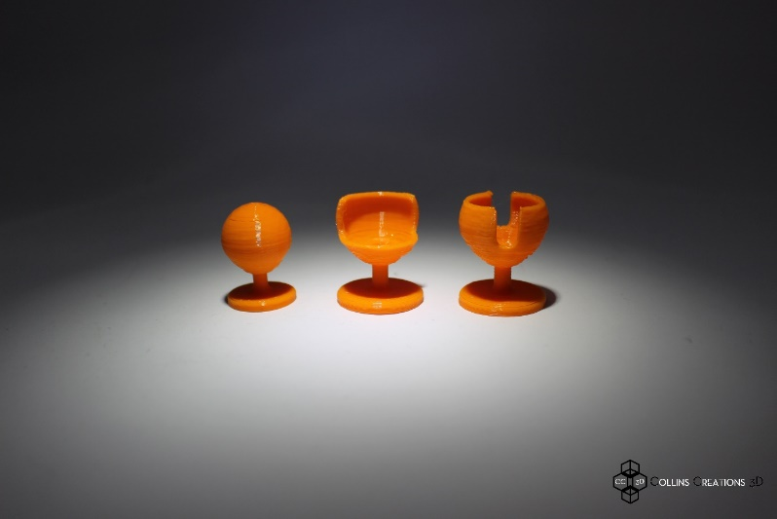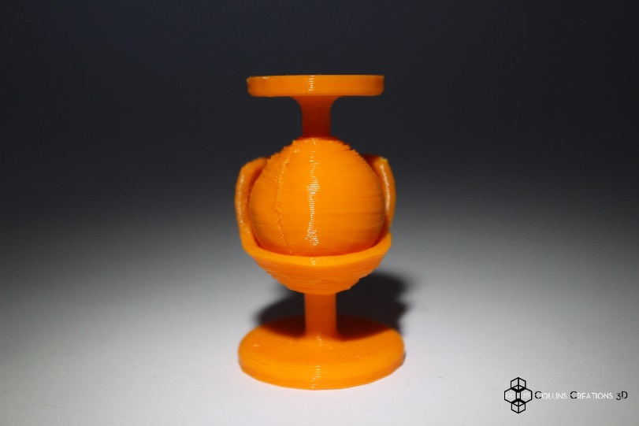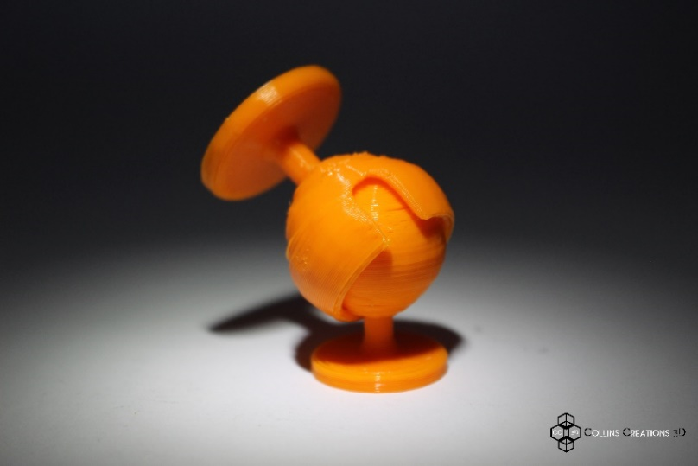

In the case of a ball and socket joint, you can get as low as 0.25mm, however, with joint spaces below this recommended value we sometimes find that any artefacts formed within the joint space can result in unwanted friction thereby reducing dynamic motion or worse partial joint fusion.

INFILLING

Any solid 3D STL. file(s) can be printed with numerous fill densities, from 0% to 100%. This affects the strength, weight, transparency and elastic modulus of your chosen printed object.

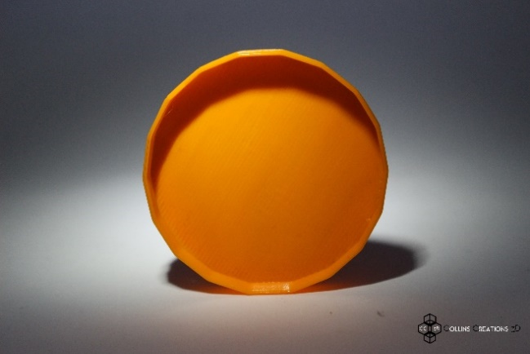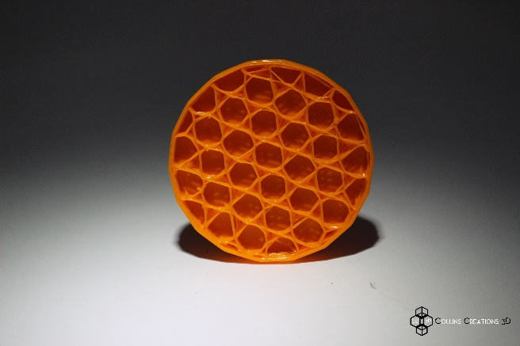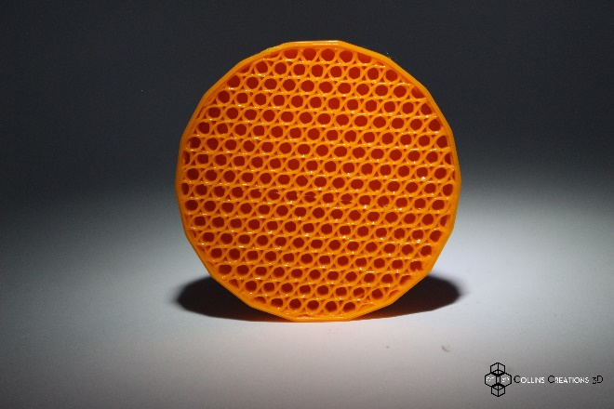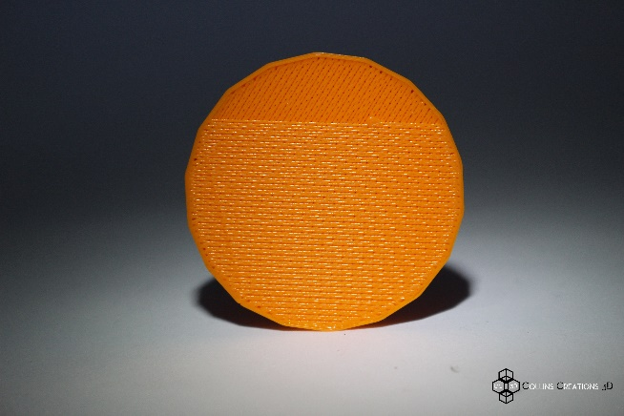

TIP: keep in mind that if you apply infills to your prints, this will require more printing material and time to complete your prints. So when you place an order just keep in mind what the purpose of your chosen project is.

SIZE OF PRINTS

3D Printing using FDM techniques limits the size of single prints to 200mm x 200mm x 200mm volume. So keep this in mind when designing your objects. If your object’s scale is paramount and the total size exceeds this maximum build volume then, we will divide your object into smaller sections that can be assembled post print.

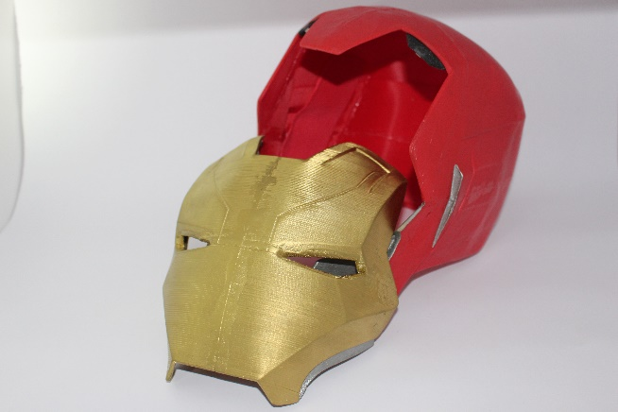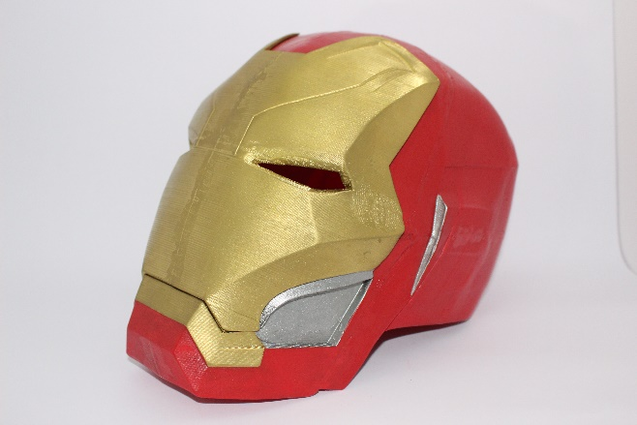

TIP: don’t forget, the bigger the print the more time and material will be required, so if size isn’t a necessity then consider scaling down.

SECURE BASE

‘No one likes a soggy bottom’ and with FDM manufacture we require the base of your designs to anneal well with the printing bed. Typically this means objects with larger base surface areas are more stable, require less support structures and so usually have less blemishes. Without supportive bases, the chance of prints failing is much higher, so before we start a print we shall inform you how we will need to proceed to get the best print results, normally this will require the object to be re-orientated on the print bed.

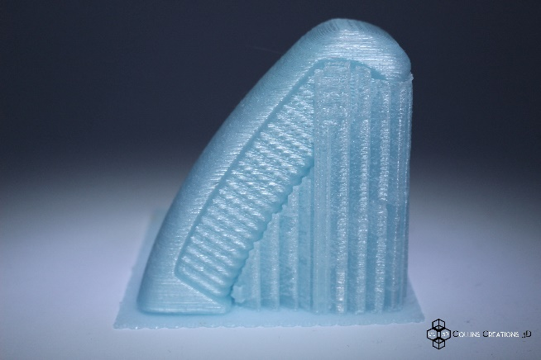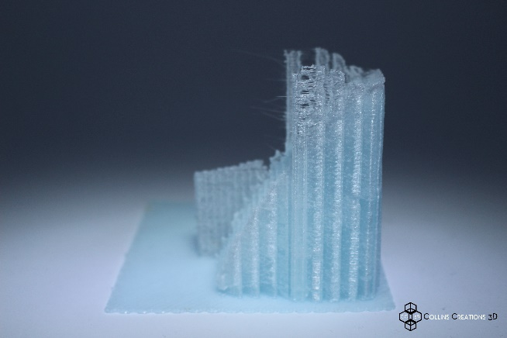

TIP: when designing and sending files to us, try to optimise the orientation to include the largest base surface area possible within the constraints of the build volume (200mm x 200mm x 200mm). This will save us time and you money!

ADDITIONAL INFORMATION

The services provided to you by Collins Creations 3D offer unique opportunities to local businesses and individuals who want to innovate, create and experiment with 3D design, manufacture and prototyping. By specialising and utilising 3D Scanning and Printing technologies and methodologies in tandem with one another CC3D can offer you advanced manufacturing services that have not yet been seen in Cornwall, something we hope to change with your help and support.

Feel free to contact us with further questions, feedback or if you have a design project in mind as an individual, group or business then contact us using the details at the bottom of the page.

